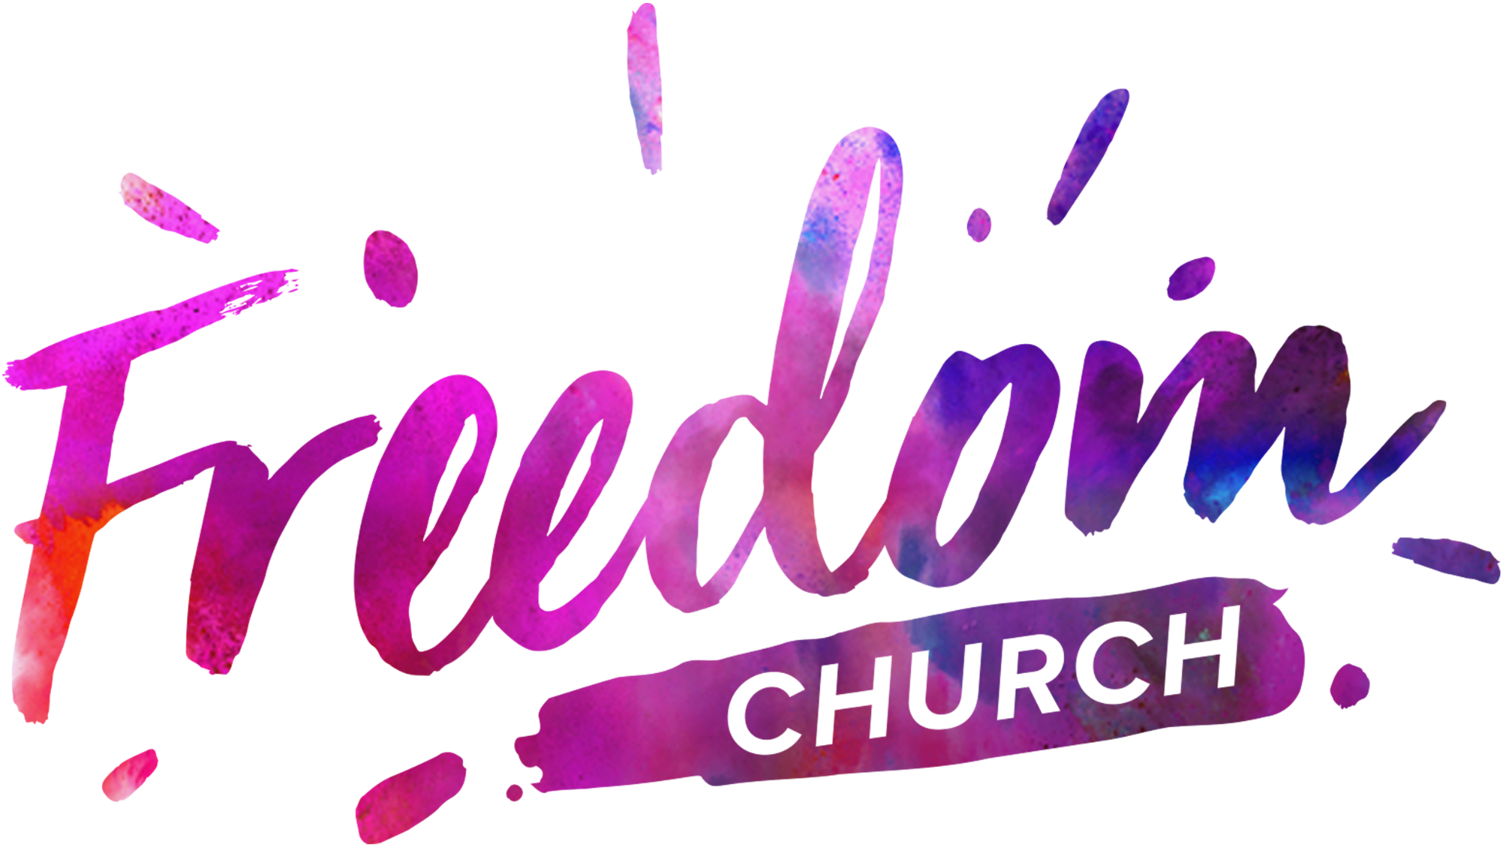
Parental Consent: SPACE ADVENTURE SUMMER HOLIDAY BIBLE CLUB
Monday 24 – Wednesday 26 August 2026, 9 am – 12:30 pm,
Studio 5, The Kingswood Estate, Britannia Road, Kingswood BS15 8DB

PLEASE COMPLETE A SEPARATE FORM FOR EACH YOUNG PERSON
Once completed, please return this form by email to L.Morgan@wearefreedomchurch.co.uk
Days Attending
(please tick the box for each day you would like to register this young person)
☒ Day 1: Mon 24th August | Day 2: Tues 25th August | Day 3: Wed 26th August
Plans change! Just let us know when you can if you would like to add/remove days booked: L.Morgan@wearefreedomchurch.co.uk

Young Person's Details
Name
Date of Birth | Age at Event
Address

Parent/Carer Details
Name
Contact address (if different from above)

Email address
EMERGENCY CONTACT PHONE NUMBERS – SWITCHED ON DURING THE EVENT
Mobile | Home | Work

Alternative Contact Details
If parent/carer unavailable, please contact:
Name
Relation to young person
EMERGENCY CONTACT PHONE NUMBERS – SWITCHED ON DURING THE EVENT
Mobile | Home | Work
Registered address: Freedom Church Bristol,
Acorn House, The Kingswood Estate, Britannia Road, Bristol, BS15 8DB

GP Details
Name
Address

Phone

Particular Needs and Adaptations
Any known conditions, allergies etc. (e.g. asthma, diabetes, epilepsy) & any medication being taken
Any other special needs, requirements or directions that would be helpful for the leaders to know
Details of any behavioural issues that may help us to care for your young person

SPECIFIC CONSENTS
Medical: In signing below, I authorise an adult leader to sign on my behalf any written form of consent required by the hospital, if I cannot be contacted and my young person should require emergency hospital treatment. I understand that every effort will be made to contact me as soon as possible.
Photography: I understand that it is Freedom Church's policy to allow filming and photography of church productions and events. * Please tick ONE box
I consent to recordings and photographs of my child participating in this event to be used in church publicity
I do not consent to recordings and photographs of my child participating in this event to be used in church publicity
Independent Travel * Please tick ONE box
I consent to my young person making their own way home
I do not consent to my young person making their own way home
DECLARATIONS
- I confirm that the above details are correct to the best of my knowledge.
- I will inform the leaders of any important changes to my young person's health, medication or needs, and of any changes to contact details given above: L.Morgan@wearefreedomchurch.co.uk
- I consent to the young person named above attending Freedom Church Bristol's Summer Holiday Bible Club
Parent/Guardian Signature  (may be typed if submitted electronically) | Date
Name printed in full
Any further information you would like to bring to our attention:

PLEASE COMPLETE A SEPARATE FORM FOR EACH YOUNG PERSON
Once completed, please return this form by email to L.Morgan@wearefreedomchurch.co.uk

